## Smartphones in the Age of Mobility and Smart Devices: An Overview

A smartphone can be simply considered as a mobile phone with highly advanced features. Beal (n.d.) has described smartphones as a handheld device that integrates mobile phone capabilities with the more common features of a handheld computer or PDA. A smartphone is expected to have a more powerful CPU, more storage space, more RAM, greater connectivity options and larger screen. Smartphones are more powerful than regular cellular phones and PDAs in almost every aspects such as efficiency, reliability, user friendly and etc. A typical smartphone now a days generally has a high-resolution touch screen display, Wi-Fi connectivity, Web browsing capabilities, and the ability to accept sophisticated applications. The most popular mobile operating systems at the time being are Android, iOS and Windows Mobile.

The fine integration of these powerful hardware and software has paved a way to introduce sophisticated mobile devices with number of different services all in just one device. Those provided features along with the rapid developments in the internet technologies have amplified the usage of smartphone in the society. According to Gartner, a leading information technology research and advisory company, smartphones accounted for 53.6 percent of the overall mobile phone sales in 2013, which exceeded the annual sales of feature phones. Gartner revealed the global sales of smartphones to end users reached 968 million units during 2013, which is an increase of 42.3 percentage points from 2012's figure of 680 million.

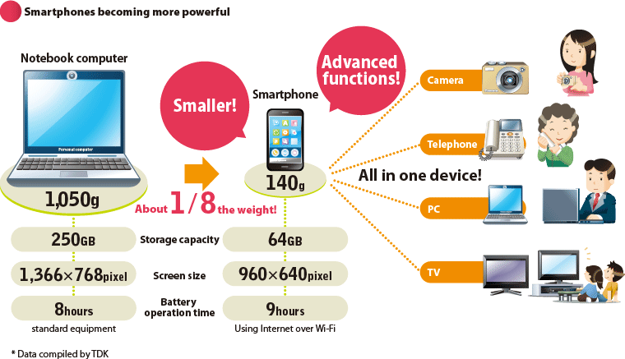

Figure 2.1: Smartphones Becoming More Powerful  
Source: http://www.global.tdk.com/

The above figure illustrate how smartphones are becoming more powerful day by day with the improvements in the technology field. Some of the common uses of smartphones are GPS to find your way, access your business data at any time, you will be able to conduct last minute researches, schedule keeping, managing the social collaborations and maintaining your schedules.

These trends make clear that these handheld devices and their technologies have become common currency in popular usage. Furthermore, they have penetrated every aspect of human existence. The widespread use of handheld devices in almost all major industries and sectors including financial services is a testimony for the ubiquitous applicability and popularity of mobile technologies.

Susan, a VP in Business Development at Scisbo Business Solutions states some applications of smartphone technologies which can be seen in the society. She mentions that medical doctors are able to monitor patients' health with heartbeat monitors, sleep monitors, and pedometers that connect to the cloud via a smartphone and send an alert when there’s a problem. People with chronic conditions such as diabetes can use a smartphone to monitor their blood sugar, making fewer trips to the clinic.

Furthermore she describes that smartphone docks in cars are valuable for more than just phone calls and entertainment. Now, they can be used for monitoring and diagnostics for the car itself or to track driving patterns for pay-as-you-drive insurance programs. Apart from that she also states that small size business reduce the energy use in commercial buildings by installing intelligent thermostats and heating controllers that can be programmed and monitored with apps and also smartphones can control door locks remotely or even control and monitor a whole security camera network.

It is the latest trend to develop smartphone applications which will communicate with your main server with the aid of a web service. Smartphone apps have been created to solve a problem, increase productivity, offer an intrinsic benefit, or for pure entertainment. Apple's IPhone store alone has more than 150,000 apps available for download and users have downloaded more than 3 billion apps. A custom application for your business can be developed to suit your need with minimum cost.

These results further strengthen the notion that use of handheld devices can greatly enhance the productivity of the business process and the productivity of employees. With the real time access to crucial business statistics, employees are given the opportunity to make informed decisions that greatly contribute to the overall productivity of business operations.

Considering breath of its features, it is clear to the researcher that smartphones have the capacity to be utilized in many areas of work as it is frequently seen that some government institutions and business organizations extensively use web services bases smartphone applications to enhance their customer interaction, productivity of the business and provide a strategic value to their businesses.

References

‘Gartner’ 2014, *Gartner Says Annual Smartphone Sales Surpassed Sales of Feature Phones for the First Time in 2013,* Viewed 29th October 2014

<http://www.gartner.com/newsroom/id/2665715>

Susan W. 2013, Widespread *Adoption of Tablets and Smartphones Is Driving Growth in the Internet of Things,* Viewed 29th October 2014

<https://www.scisbo.com/web/business-solutions/blog/-/blogs/widespread-adoption-of-tablets-and-smartphones-is-driving-growth-in-the-internet-of-things>

TDK Global 2012*, Devising Total Solution for Condensing a Multitude of Function within a Limited Space,* Viewed 29th October 2014

http://www.global.tdk.com/ir/ir_library/annual/2012/html/strategy/str01.htm